HLD (High-Level Design)

Project: Cryptocurrency Volatility Prediction
Overview:
- Input: daily OHLC + volume + market_cap CSV for multiple symbols.
- Processing: ingest → clean → feature_engineering → train/test split → model training → evaluation → (optional) deployment.
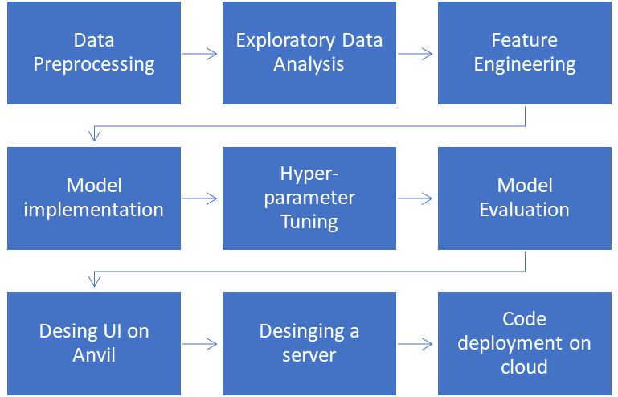

Components:
1. Data Ingestion: CSV loader (pandas), date parsing, column normalization.
2. Preprocessing & FE: cleaning script -> feature_engineering.py (log returns, vol windows, ATR, BB width).
3. Model Training: train_model.py or notebook cell that trains RandomForestClassifier and RandomForestRegressor.
4. Evaluation: evaluation module producing classification_report and regression metrics and plots.
5. (Optional) Deployment: Streamlit/Flask app to load `rf_model.pkl` and serve predictions.
Data Flow:
CSV -> cleaning -> FE -> per-symbol time-split -> model training -> model artifact (*.pkl) -> evaluation reports -> (deployment)

LLD (Low-Level Design)

/notebooks/Source Code.ipynb
- Cells:
* Data load / initial checks
* EDA visualizations
* Feature engineering
* Splitting logic per symbol
* Modeling (classification & regression)
* Hyperparameter tuning
* Explainability

/preprocessing.py (recommended)
- load_data(path)
- normalize_columns(df)
- convert_types(df)
- handle_missing(df)

/feature_engineering.py (recommended)
- compute_log_returns(df)
- compute_rolling_vol(df, windows=[7,14])
- compute_atr(df, window=14)
- compute_bollinger_width(df, window=20)
- compute_liquidity(df)
- create_targets(df, future_window=7)

/modeling/train_model.py
- functions:
train_classifier(X, y, params)
train_regressor(X, y, params)
save_model(model, path)

/evaluation/evaluate.py
- classification_report_save(y_true, y_pred)
- regression_metrics_save(y_true, y_pred)
- plot_feature_importance(model, feature_names)

Dependencies:
- Python 3.11.3
- pandas, numpy, scikit-learn, matplotlib, seaborn, joblib

How to run:
1) python preprocessing.py --input dataset.csv --output cleaned.csv
2) python feature_engineering.py --input cleaned.csv --output features.csv
3) python modeling/train_model.py --input features.csv --save model.pkl
4) python evaluation/evaluate.py --input test.csv --model model.pkl

